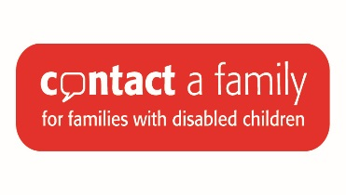

Is your child in hospital? Need advice and support?
Is there a support group near me?
Where can I get equipment?
Who can help with my DLA? form?

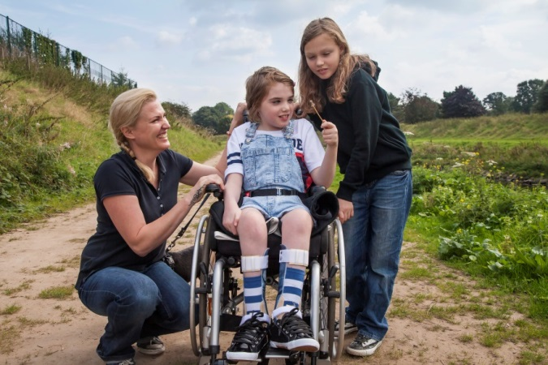
What about school?
Is there help with transport?
My washing machine’s broken
Can I get childcare?
When your child is in hospital you may be trying to cope with a whole range of issues and feelings. You can talk to us about anything, no matter how big or small.

Come and meet Contact a Family staff at our monthly information stand which will be here outside Children’s Outpatients from 9.00am-4.00pm at the RVI on the following dates this year:

Monday 21 March Tuesday 9 August
Tuesday 12 April Tuesday 13 September
Tuesday 10 May Tuesday 11 October
Tuesday 14 June Tuesday 8 November
Tuesday 12 July Tuesday 13 December

You can also contact Kath Ingleby, Hospital and Hospice Parent Advisor on 07738896474 or by email at kathleen.ingleby@cafamily.org.uk or the North East Office on 0191 2136300 or by email at northeast.office@cafamily.org.uk

Who are we?
Contact a Family is a UK-wide charity that exists to support the families of disabled children, whatever the medical or rare condition. Our vision is that families with disabled children can live the lives they want and achieve their full potential. One in 20 children in the UK is born with a disability – and we offer support, information and advice, whenever you need us, wherever you are.
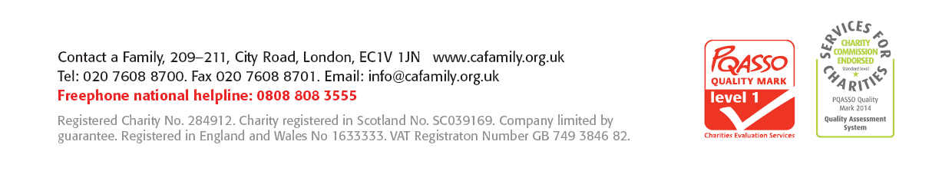
Freephone helpline 0808 808 3555 www.cafamily.org.uk

